**1.iOS 表单处理控件 tcomb-form-native**

[**tcomb-form-native**](https://github.com/gcanti/tcomb-form-native) 是 React Native 强大的表单处理控件，支持 JSON 模式，可插拔的外观和感觉。

在线演示：<http://react.rocks/example/tcomb-form-native>

AnimatedFlatList

ReactNative-Art-Progress

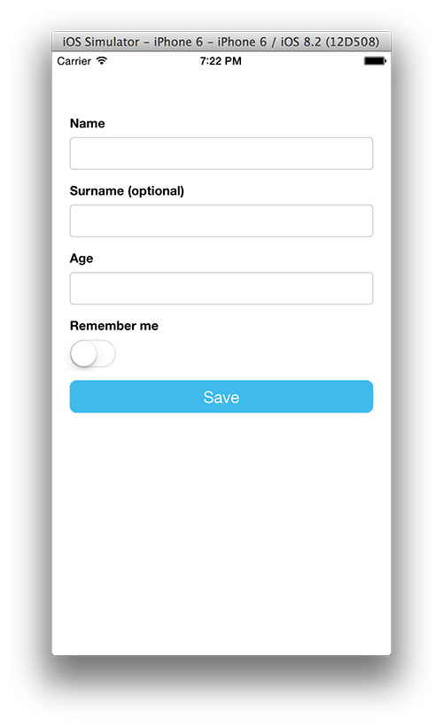

**2.摄像机视图 react-native-camera**

[react-native-camera](https://github.com/lwansbrough/react-native-camera) 是 React Native 的摄像头 viewport。这个模块应用于开发的早期阶段，它支持摄像头的转换和基本图片捕捉。

使用示例：

var React = require('react-native');

var {

AppRegistry,

StyleSheet,

Text,

View,

} = React;

var Camera = require('react-native-camera');

var cameraApp = React.createClass({

render: function() {

return (

<View>

<TouchableHighlight onPress={this._switchCamera}>

<View>

<Camera

ref="cam"

aspect="Stretch"

orientation="PortraitUpsideDown"

style={{height: 200, width: 200}}

/>

</View>

</TouchableHighlight>

</View>

);

},

_switchCamera: function() {

this.refs.cam.switch();

}

});

AppRegistry.registerComponent('cameraApp', () => cameraApp);

**3.react-native-video**

[react-native-video](https://github.com/brentvatne/react-native-video) 是 <Video>标签控件。

示例：

// Within your render function, assuming you have a file called

// "background.mp4" in your project

<Video source={"background"} style={styles.backgroundVideo} repeat={true} />

// Later on in your styles..

var styles = Stylesheet.create({

backgroundVideo: {

resizeMode: 'cover', // stretch and contain also supported

position: 'absolute',

top: 0,

left: 0,

bottom: 0,

right: 0,

},

});

**4.导航控件 react-native-navbar**

[react-native-navbar](https://github.com/react-native-fellowship/react-native-navbar) 是用于 React Native 上简单的定制化导航栏。

示例代码：

var NavigationBar = require('react-native-navbar');

var ExampleProject = React.createClass({

renderScene: function(route, navigator) {

var Component = route.component;

var navBar = route.navigationBar;

if (navBar) {

navBar = React.addons.cloneWithProps(navBar, {navigator: navigator,

route: route

});

} return (<View style={styles.navigator}>

{navBar}<Component navigator={navigator} route={route} />

</View>

);

}, render: function() {return (<Navigator

style={styles.navigator}

renderScene={this.renderScene}

initialRoute={{

component: InitialView,

navigationBar: <NavigationBar title="Initial View"/>

}}

/>

);

}

});

**5.React Native 轮播控件 react-native-carousel**

[react-native-carousel](https://github.com/nick/react-native-carousel) 是一个简单的 React Native 轮播控件。

示例代码：

var Carousel = require('react-native-carousel');var ExampleProject = React.createClass({

render() {

return (

<Carousel width={375} indicatorColor="#ffffff" inactiveIndicatorColor="#999999">

<MyFirstPage />

<MySecondPage />

<MyThirdPage />

</Carousel>

);

}

});

**6.下拉刷新组件 react-native-refreshable-listview**

[react-native-refreshable-listview](https://github.com/jsdf/react-native-refreshable-listview) 是下拉刷新 ListView，当数据重载的时候显示加载提示。

# [react-native-ultimate-listview](https://github.com/gameboyVito/react-native-ultimate-listview)

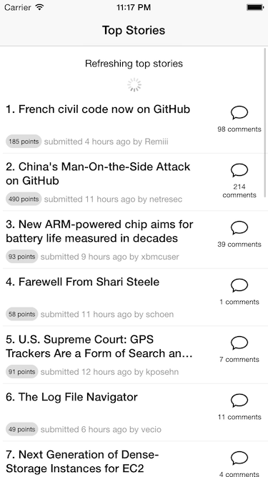

**7.Modal 组件 react-native-modal**

[react-native-modal](https://github.com/brentvatne/react-native-modal) 是 React Native 的 <Modal> 组件。



**8.文本解析控件 react-native-htmltext**

[react-native-htmltext](https://github.com/siuying/react-native-htmltext) 可以用 HTML 像 markup 一样在 ReactNative 里创建出相应效果的样式文本。ReactNative 为那些样式文本提供一个文本元素，用于取代 NSAttributedString，你可以创建嵌套的文本：

<Text style={{fontWeight: 'bold'}}>

I am bold

<Text style={{color: 'red'}}> and red </Text>

</Text

**9.react-native-htmlview**

[react-native-htmlview](https://github.com/jsdf/react-native-htmlview) 是一个将 HTML 目录作为本地视图的控件，其风格可以定制。



**10.LinearGradient 组件 react-native-linear-gradient**

[react-native-linear-gradient](https://github.com/brentvatne/react-native-linear-gradient) 是一个 React Native 的 LinearGradient 组件。



**11.双向循环播放 react-native-looped-carousel**

[react-native-looped-carousel](https://github.com/appintheair/react-native-looped-carousel) 是基于 React Native 的双向循环播放控件。

示例代码：

'use strict';var React = require('react-native');var Carousel = require('react-native-looped-carousel');var Dimensions = require('Dimensions');var {width, height} = Dimensions.get('window');var {

AppRegistry,

StyleSheet, Text,

View

} = React;var carouselTest = React.createClass({ render: function() { return ( <Carousel delay={500}>

<View style={{backgroundColor:'#BADA55',width:width,height:height}}/>

<View style={{backgroundColor:'red',width:width,height:height}}/>

<View style={{backgroundColor:'blue',width:width,height:height}}/>

</Carousel>

);

}

});

AppRegistry.registerComponent('carouselTest', () => carouselTest);

如果你知道其他 React Native 插件，在评论与大家分享一下吧！

文

作者： IT程序狮   
链接：http://www.imooc.com/article/2223  
来源：慕课网

进度条组件

<https://github.com/oblador/react-native-progress>

<https://github.com/bgryszko/react-native-circular-progress>

<https://github.com/oblador/react-native-image-progress>

<https://github.com/Daemon1993/ReactNative-Art-Progress>

流程组件

<https://github.com/24ark/react-native-step-indicator>

http://bbs.reactnative.cn/topic/3402/基于react-native搭建的p2p开源app

一个基于React-Native的互联网金融P2P项目

<https://github.com/seawind8888/lanmaolicai>

react-native-parallax-scroll-view

<https://github.com/jaysoo/react-native-parallax-scroll-view>

https://github.com/siuying/react-native-htmltext

<https://github.com/jsdf/react-native-htmlview>

下拉框

npm i react-native-modal-dropdown –save

eact-native-dropdown-menu

选择城市

import ChinaRegionWheelPicker from 'rn-wheel-picker-china-region';

<https://github.com/LiuC520/react-native-city-pick>

用于React Native练习的新闻类APP，接口来自都市频道。

<https://github.com/ljunb/react-native-iCityAction>

# [React Native常用第三方组件汇总--史上最全](http://blog.csdn.net/chichengjunma/article/details/52920137)

2016-10-25 11:28 6044人阅读 [评论](http://blog.csdn.net/chichengjunma/article/details/52920137#comments)(0) [收藏](javascript:void(0);) [举报](http://blog.csdn.net/chichengjunma/article/details/52920137#report)

http://static.blog.csdn.net/images/category_icon.jpg 分类：

React Native（24） http://static.blog.csdn.net/images/arrow_triangle%20_down.jpg app（22） http://static.blog.csdn.net/images/arrow_triangle%20_down.jpg node（3） http://static.blog.csdn.net/images/arrow_triangle%20_down.jpg

版权声明：本文为博主原创文章，未经博主允许不得转载。

[**React Native**](http://lib.csdn.net/base/reactnative) 项目常用第三方组件汇总：

[**React**](http://lib.csdn.net/base/react)-native-animatable 动画

react-native-carousel 轮播

react-native-countdown 倒计时

react-native-device-info 设备信息

react-native-fileupload 文件上传

react-native-icons 图标

react-native-image-picker 图片选择器

react-native-keychain [**iOS**](http://lib.csdn.net/base/ios) KeyChain管理

react-native-picker滚轮选择器

react-native-picker-[**Android**](http://lib.csdn.net/base/android) Android 滚轮选择器

react-native-refreshable-listview 可刷新列表

react-native-scrollable-tab-view 可滚动标签

react-native-side-menu 侧栏

### [PoSideMenu](https://github.com/pofabs/PoSideMenu)

### [react-native-flip-side-menu](https://github.com/Infinity0106/react-native-flip-side-menu)

# react-native-animatable

react-native-swiper 轮播

react-native-video 视频播放

react-native-viewpager 分页浏览

react-native-scrollable-tab-view    可滑动的底部或上部导航栏框架

react-native-tab-navigator    底部或上部导航框架(不可滑动)

react-native-check-box         CheckBox

react-native-splash-screen   启动白屏问题

react-native-simple-router     简易路由跳转框架

react-native-storage             持久化存储

react-native-sortable-listview   分类ListView  
  
react-native-htmlview               将 HTML 目录作为本地视图的控件，其风格可以定制

react-native-easy-toast         一款简单易用的 Toast 组件，支持 Android&iOS.

选项卡   https://github.com/exponentjs/react-native-tab-navigator

### material组件库（各种漂亮的小组件）https://github.com/xinthink/react-native-material-kit base组件库（各种封装不错的小组件）http://nativebase.io/docs/v0.4.6/components#anatomy https://github.com/GeekyAnts/NativeBase 不错的按钮 https://github.com/mastermoo/react-native-action-button https://github.com/ide/react-native-button [react-native-fan-button](https://github.com/ggomaeng/react-native-fan-button)

**react-native-slide-button**

react-native-menu-button

# [react-native-slider-button](https://github.com/agentS/react-native-slider-button)

输入框表单验证  
https://github.com/gcanti/tcomb-form-native  
https://github.com/FaridSafi/react-native-gifted-form  
https://github.com/bartonhammond/snowflake  
  
  
炫酷效果的 TextInput  
https://github.com/halilb/react-native-textinput-effects  
https://github.com/zbtang/React-Native-TextInputLayout  
  
  
聊天  
https://github.com/FaridSafi/react-native-gifted-chat  
  
  
地图  
https://github.com/lelandrichardson/react-native-maps  
  
  
动画  
https://github.com/oblador/react-native-animatable  
  
  
加载动画  
https://github.com/maxs15/react-native-spinkit  
  
  
抽屉效果  
https://github.com/root-two/react-native-drawer  
https://github.com/react-native-fellowship/react-native-side-menu  
  
  
侧滑按钮  
https://github.com/dancormier/react-native-swipeout  
https://github.com/jemise111/react-native-swipe-list-view  
  
  
图表  
https://github.com/tomauty/react-native-chart  
  
  
下拉放大  
https://github.com/lelandrichardson/react-native-parallax-view  
  
  
日历组件  
https://github.com/cqm1994617/react-native-myCalendar

https://github.com/vczero/react-native-calendar  
  
  
语言转化和一些常用格式转换  
https://github.com/joshswan/react-native-globalize  
  
  
单选多选ListView  
https://github.com/hinet/react-native-checkboxlist  
  
  
选择按钮  
https://github.com/sconxu/react-native-checkbox  
  
  
二维码  
https://github.com/ideacreation/react-native-barcodescanner  
  
  
制作本地库  
https://github.com/frostney/react-native-create-library  
  
  
影音相关  
https://github.com/MisterAlex95/react-native-record-sound  
  
  
[**安卓**](http://lib.csdn.net/base/android)录音  
https://github.com/bosung90/react-native-audio-android  
  
  
提示消息的Bar  
https://github.com/KBLNY/react-native-message-bar  
  
  
iOS原生TableView  
https://github.com/aksonov/react-native-tableview  
  
  
点击弹出视图  
https://github.com/jeanregisser/react-native-popover  
https://github.com/instea/react-native-popup-menu  
  
  
3D Touch  
https://github.com/madriska/react-native-quick-actions  
  
  
双平台兼容的ActionSheet  
https://github.com/beefe/react-native-actionsheet  
  
  
照片墙  
https://github.com/ldn0x7dc/react-native-gallery  
  
  
键盘遮挡问题  
https://github.com/reactnativecn/react-native-inputscrollview  
https://github.com/wix/react-native-keyboard-aware-scrollview  
  
  
本地存储  
https://github.com/sunnylqm/react-native-storage  
  
  
星星  
https://github.com/djchie/react-native-star-rating  
  
  
国际化  
https://github.com/joshswan/react-native-globalize  
  
  
扫描二维码  
https://github.com/lazaronixon/react-native-qrcode-reader  
  
  
通讯录  
https://github.com/rt2zz/react-native-contacts  
  
  
加密  
https://www.npmjs.com/package/crypto-js

# 缓存管理 https://github.com/reactnativecn/react-native-http-cache ListView的优化 https://github.com/sghiassy/react-native-sglistview 图片和base64互转 https://github.com/xfumihiro/react-native-image-to-base64 安卓 iOS 白屏解决 https://github.com/mehcode/rn-splash-screen Text跑马灯效果 https://github.com/remobile/react-native-marquee-label 清除按钮的输入框 https://github.com/beefe/react-native-textinput WebView相关 https://github.com/alinz/react-native-webview-bridge 判断横竖屏 https://github.com/yamill/react-native-orientation PDF https://github.com/cnjon/react-native-pdf-view 获取设备信息 https://github.com/rebeccahughes/react-native-device-info 手势放大缩小移动 https://github.com/kiddkai/react-native-gestures https://github.com/johanneslumpe/react-native-gesture-recognizers 下拉-上拉-刷新 https://github.com/FaridSafi/react-native-gifted-listview https://github.com/jsdf/react-native-refreshable-listview https://github.com/greatbsky/react-native-pull/wiki 下拉选择 https://github.com/alinz/react-native-dropdown 图片查看 https://github.com/oblador/react-native-lightbox 照片选择 https://github.com/marcshilling/react-native-image-picker https://github.com/ivpusic/react-native-image-crop-picker 图片加载进度条 https://github.com/oblador/react-native-image-progress [react-native-progress-bar](https://github.com/lwansbrough/react-native-progress-bar)

react-native-progress-circular

react-native-loading-spinner-overlay

  
轮播视图  
https://github.com/race604/react-native-viewpager  
https://github.com/FuYaoDe/react-native-app-intro  
https://github.com/appintheair/react-native-looped-carousel  
https://github.com/leecade/react-native-swiper  
  
  
模态视图  
https://github.com/maxs15/react-native-modalbox  
https://github.com/brentvatne/react-native-modal  
https://github.com/bodyflex/react-native-simple-modal  
  
  
毛玻璃效果  
https://github.com/react-native-fellowship/react-native-blur  
  
  
头像库  
https://github.com/oblador/react-native-vector-icons  
  
  
滑动选项卡  
https://github.com/skv-headless/react-native-scrollable-tab-view

A ScrollView-like component that:  
Has a parallax header  
Has an optional sticky header  
Is composable with any component that expects a ScrollView (e.g. ListView or InfiniteScrollView)  
Can be nested within other views  
Works on iOS and Android

react-native-parallax-scroll-view

工程目录下终端输入  npm i  XXX  save

另附链接：

<https://github.com/jondot/awesome-react-native>

# React Native开源秒杀倒计时模块(react-native-CountDowntimer)

react-native-highcharts 图表组件

react-native-pathjs-charts

